**Ideation Phase**

**Define the Problem Statements**

|  |  |
| --- | --- |
| Date | 20 May 2023 |
| Team ID | NM2023TMID13273 |
| Project Name | THE FUTURE OF WORK:DATA ANALYSIS OF GLASSDOOR JOB |
| Maximum Marks | 2 Marks |

**Customer Problem Statement :**

Create a problem statement to understand your customer's point of view. Many individuals and organizations face significant challenges when it comes to effectively managing and classifying garbage. Traditional methods of garbage classification are often time-consuming, error-prone, and require significant human intervention. This results in inefficiencies, increased labor costs, and environmental concerns due to improper waste management. Customers are seeking an intelligent garbage classification solution that can automate and streamline the process, accurately identifying different types of garbage using deep learning techniques. Graphical user interface, text, application, email

**Example:**

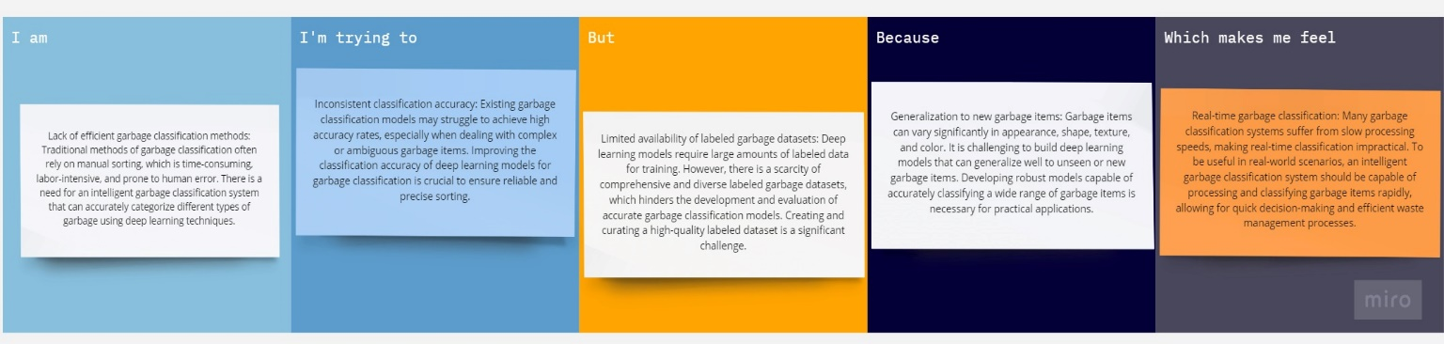

|  |  |  |  |  |  |
| --- | --- | --- | --- | --- | --- |
| **Problem Statement (PS)** | **I am (Customer)** | **I’m trying to** | **But** | **Because** | **Which makes me feel** |
| PS-1 | A waste management company | Improve garbage classification efficiency | Existing methods are time-consuming and prone to error | This affects our operational efficiency and accuracy in sorting | Frustrated and inefficient |
| PS-2 | A researcher in environmental sciences | Develop an accurate garbage classification model | Current models struggle with ambiguous or complex garbage items | It hinders accurate research and analysis of waste composition | Limited in my research and understanding of waste composition |